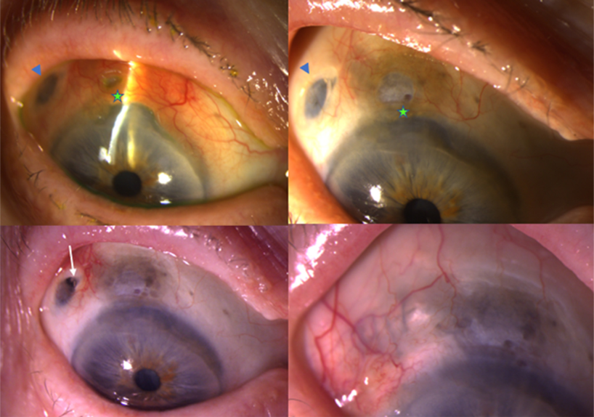

A 91-year-old woman with neovascular age-related macular degeneration presented with worsening right eye redness and irritation 4months after implantation of a ranibizumab port delivery system. Corneoscleral thinning and conjunctival injection (A, green star) wasnoted adjacent to the implant (A, blue arrowhead). Laboratory workup showed positive perinuclear antineutrophil cytoplasmic antibodieswith negative workup for other causes of vasculitis. The patient was administered oral and topical steroids with improvement inconjunctival injection, but (B) the corneoscleral and conjunctival thinning progressed, resulting in erosion of the implant (C, white arrow)and subsequent removal. (D) At 3 months postoperatively, the corneoscleral thinning remained stable after discontinuation of oral steroids.Based on the provided images and clinical description please make an ophthalmic diagnosis for this patient. And output the diagnostic conclusions only.

**Scleritis with sterile inflammation and melting following ranibizumab port delivery system implantation.**